File Name: ÊÖ»ú¶ËF2FS¾µÏñÎÄ¼þÊý¾ÝÈ¡Ö¤·½·¨.pdf
Website: http://www.css.ccidgroup.com/EN/Y2020/V11/I8/11 (4/13/2021)
Translated from Chinese(Simplified) using Google Translate.
Abstract: F2FS file system is a new open source Flash file system based on NAND storage device design, with good The performance and Flash-friendly features have attracted the attention of more and more mobile phone manufacturers. In mobile phone data forensics, people are There are few researches on the data analysis of the mirror file of the software system, and the data analysis of the files deleted by the F2FS file system is supported recently.
The research is also inadequate. The article is based on the unique read-write access mechanism of the F2FS file system and the garbage collector of the mobile phone graphical interface It proposes a general data analysis and forensics framework for mirror files of the F2FS file system. The experimental results show that the method can be accurate Correctly analyze the directory structure of the F2FS file system, realize the data forensics of the recently deleted files, and effectively support the fetch Certificate research.
Keywords: F2FS file system; mirror file data forensics; deleted file data forensics
Chinese Library Classification Number: TP309.3 Document Identification Code: B
Data forensics method of mobile terminal F2FS image file
Zhai Yujia1,2,3, Li Tao1,2,3, Hu Aiqun1,2,3
〔School of Cyber Science and Technology, Southeast University, Jiangsu Nanjing 211189; Purple Mountain Laboratories for Network and Communication Security, Jiangsu Nanjing 211111; Research Base of International Cyberspace Governance （Southeast University）, Jiangsu Nanjing 211189 〕
Abstract: The Flash Friendly File System (F2FS) is a new type of open source Flash file system based on
NAND storage device design, with good performance and Flash-friendly features. In the mobile phone
data forensics, there are few related researches on data analysis of F2FS mirror files, and related research on the analysis of F2FS's recent deleted data is also insufficient. According to the unique read-write access principle of F2FS and the garbage collection mechanism of the graphical interface, this paper builds a general forensics framework for data analysis of F2FS mirror files. The experimental results show that this F2FS mirroring forensics method can effectively analyze the directory structure and files data. The method has high accuracy and can be effective support the forensic research of F2FS.
Key words: F2FS; data forensics of image files; data forensics of deleted files
1 Introduction
F2FS file system (Flash Friendly File System)
Is a new open source Flash file system [1], and traditional Linux Compared with the file system, the F2FS file system makes better use of flash storage.

Performance advantages of storage equipment. Huawei takes the lead in adding F2FS file system
Into their own products, then a large number of manufacturers also adopted the file System to replace the Ext4 file system [2]. So far, how many The mobile devices of several manufacturers have used the file system, including three Star Galaxy Note 10, Huawei Mate20, Moto Z, etc. Have Convert from Ext4 to F2FS. With the F2FS file system on the mobile phone Widely used for building mobile phone F2FS file system for general forensics The framework is of great significance.
Under normal circumstances, the forensics of the mobile phone file system is mainly for The image file of the mobile phone file system performs data analysis. Miyaba The company regards the F2FS file system mirror file as a disk, Build a file system organization structure by simulating Linux mounting disks
Information, to achieve the analysis of the entire F2FS file system directory structure [3]. This method needs to traverse the entire file system according to the bitmap information, although Although the problem of portability is effectively solved, but the analysis of large-capacity documents The analysis efficiency is significantly reduced when the software is used in the system. Liang Xiaoning and others
Deleted files provide a way to analyze deleted files while recovering Data method, respectively traverse the segment summary area of ​​the F2FS file system (SSA) and the main area (Main Area), compare files and restore At the same time, it completes the analysis of deleted files [4]. Liang Xiaoning and others The proposed method only recovers and parses deleted files and does not involve Parse the existing files in the file system, and traverse SSA and The Main Area area also takes longer and is more efficient low. In summary, the current data on the mirror file of the F2FS file system The analysis related research is not enough.
This article is based on the unique read and write access mechanism of the F2FS file system And garbage collection mechanism, propose a kind of F2FS file system General forensic method for image file data analysis. Experimental result table Obviously, the F2FS file system mirroring forensics method proposed in this article can be Effectively realize the analysis of the directory structure of the F2FS file system, finish Data analysis of paired recently deleted files, which is useful for electronic forensics Practical application significance [5,6].
2 Overview of F2FS file system
2.1 F2FS file system layout structure
The smallest data storage unit in the F2FS file system is a block (Block), the default size of each block is 4K[7]. logically, F2FS file system is divided into metadata area (Meta Area) and main Data area (Main Area) two parts.
The metadata area includes super block (SB), checkpoint (CP), Node Address Table (NAT) and other five parts. Yuan The data area is generally stored in multiple consecutive blocks at the beginning of the system space It mainly stores the basic parameter configuration and segment of the F2FS file system Use basic information such as allocation information and data block addresses.
The main data area is divided into node segment area and data segment area. section. The main data area is mainly used to store user file information, The information related to file attributes is generally stored in the node section area Domain, the data information of the file is stored in the data segment area. F2FS text The file system manages files through the index relationship of Node-Date, and the node There is a mapping relationship between the segment area and the node address table [8]. Specific The layout structure is shown in Figure 1.
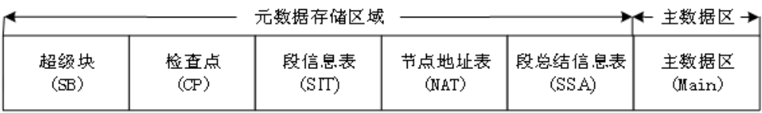
Figure 1 F2FS file system layout structure
2.2 File metadata information block
The F2FS file system uses a multi-level index mechanism to save large files Data, use inline mechanism to save small file data, file yuan number The data block is an important structure for realizing these mechanisms.
File metadata information block is also called inode_block, each The file metadata information block corresponds to a common file or directory The area of ​​metadata information block of files, ordinary files and directory files The difference is that the offset of the ordinary file in the metadata information block is 0x168
The physical memory address of the file is stored at the location, and the directory file is at the offset Store the ino node number and pair of sub-files in this directory at 0x168 Should be the file name and other information of the sub-file. General number of ordinary files According to the data structure of the information block as shown in Table 1, the catalog file metadata The data structure of the information block is shown in Table 2.
Table 1 Common file metadata information data structure
Common file metadata information data structure
Intra-block offset | Byte Length | Content Description
0x10 | 8 | File size
0x20 | 24 | Timestamp
0x5C | 255 | File name
0x168 | 3692 | 923 group index address
0x0FE8 | 20 | File identification number id
0x0FEC | 20 | File node number ino

Table 2 Data structure of catalog file metadata information block
Data structure of catalog file metadata information block
Intra-block offset | Byte Length | Content Description
0x20 | 24 | Timestamp
0x58 | 4 | Byte length of the directory name
0x5C | 255 | Directory name
0x168 | 3692 | Directory subfile information
0x0FE8 | 20 | Catalog file identification number nid
0x0FEC | 20 | Catalog file node number ino

The offset in the metadata information block of the directory file is 0x168.
The record sub-file data information area stores 182 sub-file directory entries, Used to describe the information of the sub-files in the directory, such as the name of the sub-file Hope value and sub-file node number, etc.
The nat_entry entry in the node address table stores the main data
The file node number ino and node data block corresponding to each file in the area
Address information. Combine the node information table and the sub-file directory entry, namely The directory tree of the current directory file can be constructed.
2.3 Principles of Analysis of Recently Deleted Data
After the user manually deletes the file, the F2FS file will not be cleared directly. The file memory data block in the file system only changes the file relative Off flag, clear nat_entry table entry and file metadata information The corresponding relationship of the block, only when new data is written into the deleted file After the memory data block of the file, the original information will be overwritten.
Unable to completely restore [9,10]. Taking into account the operation of deleting files on the user’s mobile phone The operation is equivalent to the user deleting the file in the graphical interface, according to the The interface deletes files not directly deletes files but puts the files first The features placed in the .Trash directory can be searched and analyzed .Trash directory file, combined with the method of valid node address table, Realize the data analysis of files deleted by users recently.

The analysis of recently deleted files referred to in this article mainly includes obtaining Delete the metadata information block of the file, the original storage path information, etc.
Basic file information. Analyze the .Trash directory file combined with the node letter There are three main methods for obtaining evidence for recent deleted file data in the information table.

Steps.
(1) Determine the node number ino and file of the .Trash directory file Metadata information block address: .Trash directory file belongs to F2FS file The sub-files of the root directory file of the file system can be based on the principle of section 2.2 Parse the metadata information block of the root directory file to determine the .Trash directory File node information number ino, get the file element corresponding to the ino Data information block address.
(2) Analyze the metadata information block of the .Trash catalog file: pass Normally, the info common subfile in the .Trash directory file is stored Store the original storage path of the deleted file; under the .Trash directory file The files subdirectory file stores the node number ino and file of the deleted file Basic information such as the file name.
(3) Obtain the metadata information block and original storage of the deleted file Storage path: Combine the node address table to analyze the number of deleted files According to the information block, get the delete time and storage address of the deleted file And other information to realize the deletion of file forensics.
2.4 F2FS file system mirror file
Mirror file is a specific series of files according to a certain format A single file produced by the style. File system image files not only include Contains the data file of the file system, and also contains the file system Basic attribute information and partition information, file system image file package Contains all the information of the file system [11].
This article simulates the mobile phone file system and produces multiple sets of F2FS files The image file of the software system is used for experimental research and result analysis, mainly Divided into three types of image files:
(1) The F2FS file system has just been created and only includes a few The initial state F2FS mirror file of a single file;
(2) Simulate repeatedly mounting, creating or modifying existing documents User operations such as files, move file locations, etc., create a used segment F2FS mirror file after time;
(3) There are large files of various types or different sizes Type F2FS mirror file.
For the above different types of image files, use Wi n H e x obtain the read-only area of ​​the super block respectively, analyze and verify The soundness and effectiveness of F2FS mirror files. Super block check
The specific process is:
(1) Check the magic number flag bit "0x1020F5F2";
(2) Check the default parameters such as sector size;
(3) Check the root index node number and each metadata index.
If the verification of the super block and the backup super block fails, the table It shows that the file system is damaged or the mirror file operation is incorrect.
3 Forensic analysis of F2FS mirror file directory entry
In order to obtain evidence for the directory entries of the mirror files, the first step is to obtain Take the effective node address table of the current F2FS, and then according to the effective section Click the nat_entry entry of the address table to get the parsed files and folders
The metadata information block, the logical relationship completes the construction of the directory tree, This chapter will mainly obtain the valid section based on the root directory file timestamp Point address table method, general F2FS mirror file directory tree forensics method These two aspects are expanded [3].
3.1 Obtain the valid node location based on the root directory file timestamp Address table
To prevent unrecoverable damage to metadata caused by downtime, Generally, there are two or more node addresses in the F2FS file system Table, but only one valid node address table stores the latest node information. Due to the influence of the jounal caching mechanism of the F2FS file system
If there is a valid nat_entry entry, it has not been updated to the node address table The phenomenon [12]. According to the writing principle of the node address table, pass the inspection The checkpoint segment locates the latest valid node address table is a mirror file The main technical difficulties in the forensic method of catalog items.
In response to the above phenomenon, this article proposes a root directory-based document The method of obtaining the valid node address table by the file timestamp, the actual The flowchart is shown in Figure 2. Get based on root directory file timestamp The steps of the effective node address method are:
(1) Determine the address table and version of each node from the super block The start address of the valid checkpoint segment with the higher number;
(2) Find the root directory node number in the effective checkpoint segment ino (0x03), record the address of the metadata information block, marked as Root Directory Metadata Information Block I;
(3) Find the root directory node number in each node address table ino (0x03), respectively record the address of each metadata information block, Marked as root directory metadata block Ⅱ, Ⅲ, etc. in turn;
(4) Compare the number of root directory metadata information blocks I, II, III, etc. According to the timestamp in the block, get the root directory metadata block location of the latest timestamp The current node address table and the cache nat_entry entry of the checkpoint segment;
(5) If the root directory timestamp of the node address table segment is the latest, Then the node address table is the currently valid node address table. If check The root directory timestamp of the checkpoint segment is the latest, you need to manually change the checkpoint segment The nat_entry entry in the cache is updated to the node address table to get the current The previous valid node address table;
(6) If the root directory timestamp is the same, compare The time stamp information of the sub-files in the root directory.

3.2 F2FS mirror directory tree forensics method
Directory forensics of F2FS file system mirror files is the most important
The important step is to determine the link relationship between the catalog items, build the most New directory tree structure. According to the above analysis, we can get a General F2FS file system mirror file directory tree forensics method, The forensic flow chart of this method is shown in Figure 3.
General F2FS file system mirror file directory tree forensics The specific steps of the law are:
(1) Load the F2FS mirror file, read the mirror file Level block, determine the checkpoint segment and the address of each node address table;
(2) Use the root directory file timestamp method to get the valid section Click the address table and read the nat_entry entry;
(3) With the root directory as the starting point of the mirror file directory tree, in The effective node address table looks up the node number ino of the root directory file, and resolves it Metadata information of the root directory;
(4) Look up the sub-files of the root directory in the valid node address table Node number ino, parse the metadata information of each sub-file;
(5) Repeatedly analyze and construct each sub-file Complete F2FS file system mirror file directory tree.
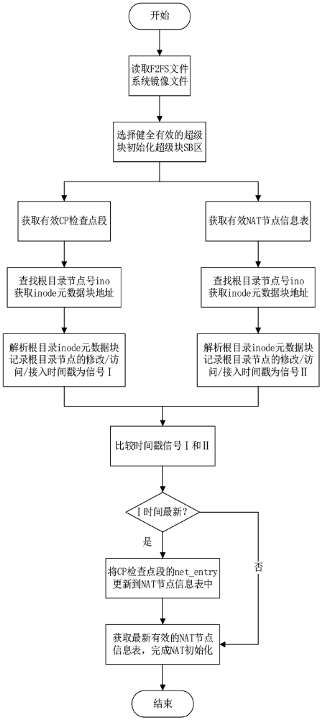
Begin

Read F2FS File (System Mirror File)

Choose a sound and effective super block initialization superblock area
Get Valid CP checkpoint segment | Get valid NAT node information table
Find the root node number ino  Get the address of the inode metadata block | Find the root directory node number ino  Get the address of the inode metadata block
Parse the root directory inode metadata block  Record the modification visit of the root directory node.  Time/access time view as signal 1 | Parse the root directory inode metadata block  Record the modification visit of the root directory node  Access timestamp for signal 1

Compare the time stamp signal 1 and 1
Identify Latest Time
Set the net entry of the CP checkpoint segment
Get the latest valid Nat node Information table complete NAT initialization

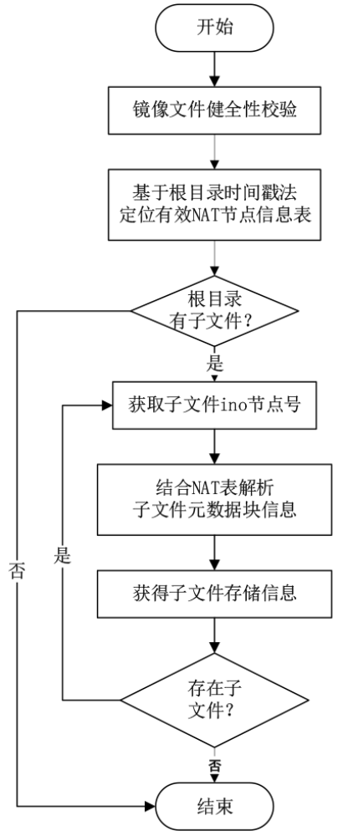
Begin
Image file sanity check
Based on the root directory pair stamping method

Locating valid NAT noted information table

Root directory
Does it have children files

Yes (Continue) No (go to end)
Get the ino node number of the child file

Combined with NAT table analysis
Subfile metadata block information

Obtain sub-file storage information

Existing file? If so go back to Get the ino number of the child file.

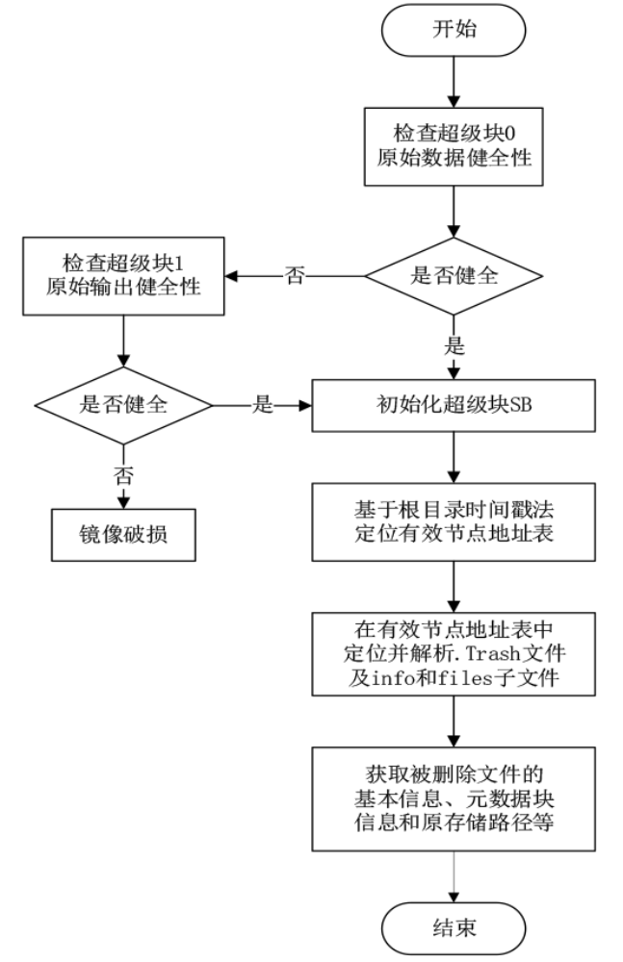
Begin

Check super block 0
Raw data sanity

Check Super block 1  Raw output soundness | Is fragrant and healthy?  (Yes go down No go to left)
It is sound  (yes go right) No, Broken Image | Initialize super block SB

Based on the root directory time stamp method Locate the valid node address table
In the valid node address table Locate and resolve the Trash file and info and sub-files
Get the deleted file
Basic information, meta data block
Information and original storage path, etc…

4 Forensic analysis of deleted files of F2FS mirror files
Data forensics of deleted files mainly refers to obtaining users’ recent Delete the metadata information and file content of the file [4]. Mirror in F2FS
Based on the analysis of the file directory structure, we further propose a F2FS mirror file deletion file forensics method, the method specific flow The process is shown in Figure 4.
F2FS file system mirror file deletion file forensics method
The specific steps are:
(1) Read the super block of the mirror file, through the root directory file Time stamp method to obtain valid nat_entry entry;
(2) Combining the effective node address table to obtain the root directory .Trash sub-file metadata information;
(3) Analyze the .Trash file metadata information block and info and The metadata information block of the files sub-file, to obtain the deleted file Metadata information block and original storage path.
5 System implementation and result analysis
5.1 Mirror file directory tree forensic results
Use F2FS mirror file directory tree forensics method to construct separately Build different types of F2FS mirror file directory tree structures to obtain Basic information of each file, including file name, size, physical Storage address, etc.
The initial F2FS mirror file directory analysis result is shown in Figure 5
Show, the result shows that the initial state F2FS file system has a folder And two files. The basic information of each file is reported in the forensic result There are detailed instructions in the report column.

Analysis of F2FS mirror file directory after using for a period of time The result is shown in Figure 6, the result shows that the F2FS after use includes Multiple folders such as myfolder, test, picture, etc., 5 texts Files and 13 picture files. The basic information of each file is taken There are detailed explanations in the column of the certificate result report.
The analysis results of the mirror file directory of the large F2FS file system are as follows As shown in Figure 7, the results show that the large F2FS includes 300 folders, Multiple text files are stored in the folder. The basic information of the file is in There are detailed instructions in the forensic result report column.
Differences in text compilers between different Linux systems, text There may be garbled characters in the name of the document. The above results show that this The F2FS mirror file directory tree forensics method proposed by the article can be realized Build a directory tree for different types of F2FS mirror files to obtain each file Software information verifies the feasibility of the method.
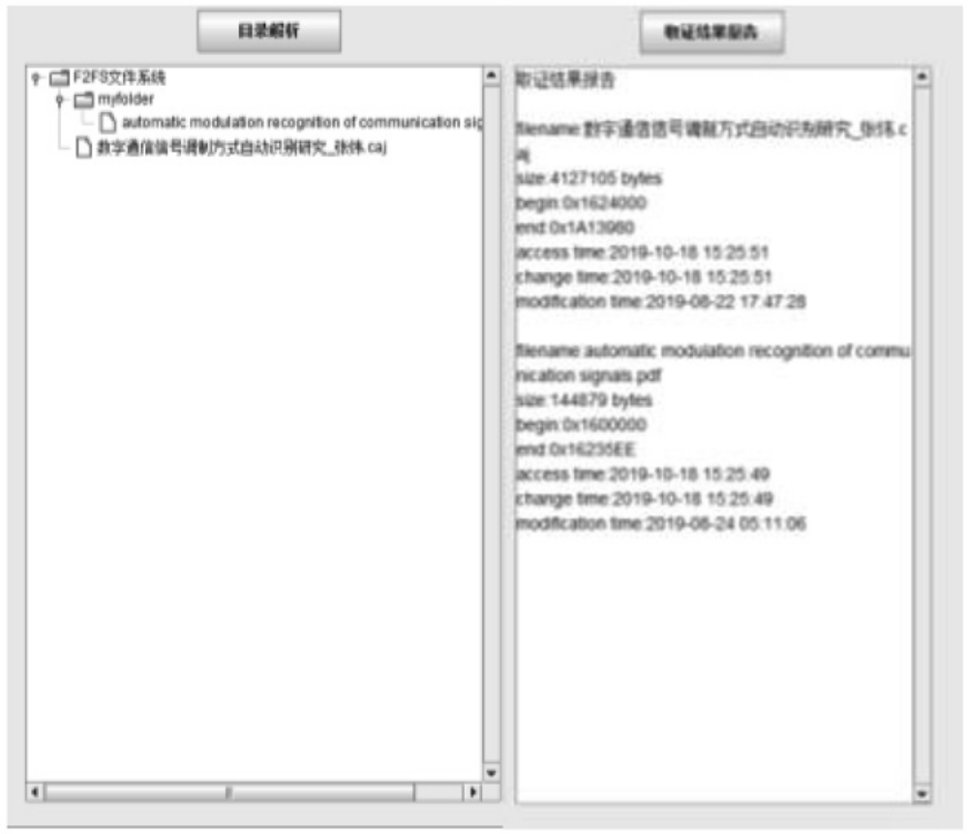

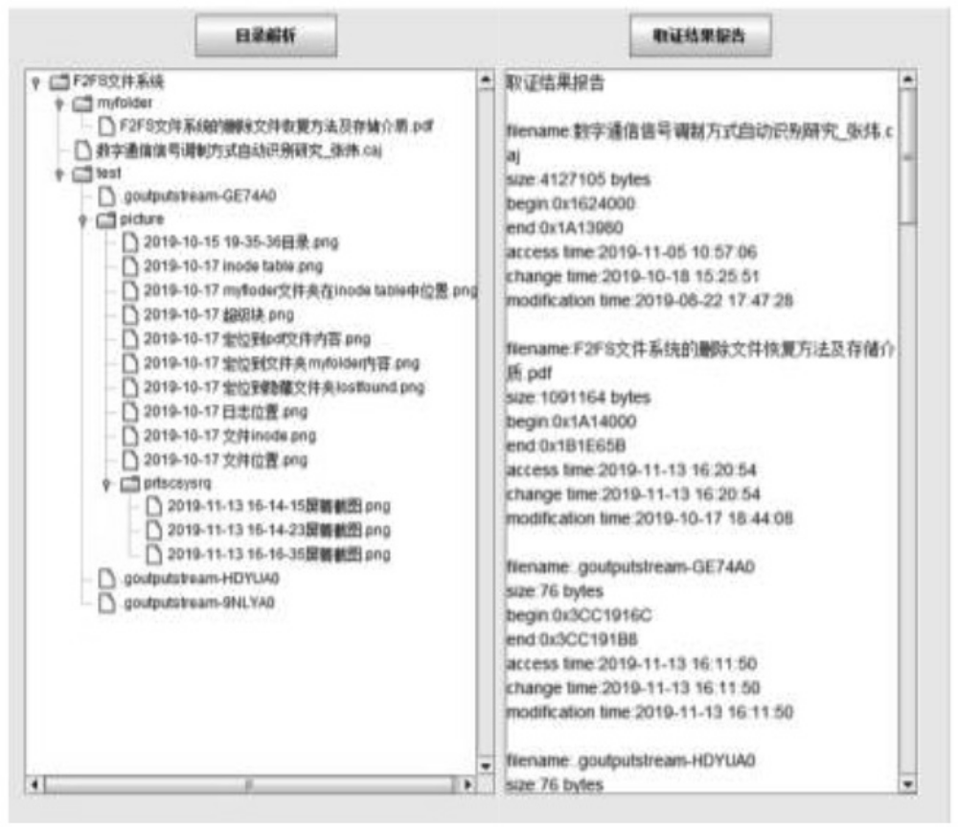

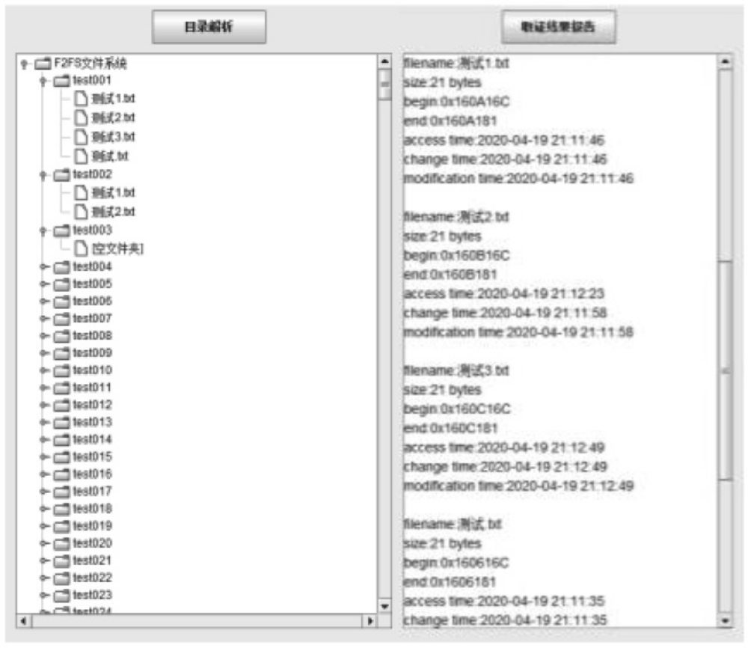

5.2 Mirror file deletion file forensics results
F2FS mirror files that have deleted multiple files recently deleted by users The file forensics result is shown in Figure 8. The result shows that the large F2FS file There are 3 users who have recently deleted files in the system, and the files have been deleted Name and corresponding original storage path information, deleted time, Basic information such as file size, file storage address, etc. is in the forensic result There are detailed instructions in the report column.
The above result figure shows that the mobile phone F2FS mirroring proposed in this paper The document data forensics method can accurately locate and obtain the recently deleted In addition to file metadata information.
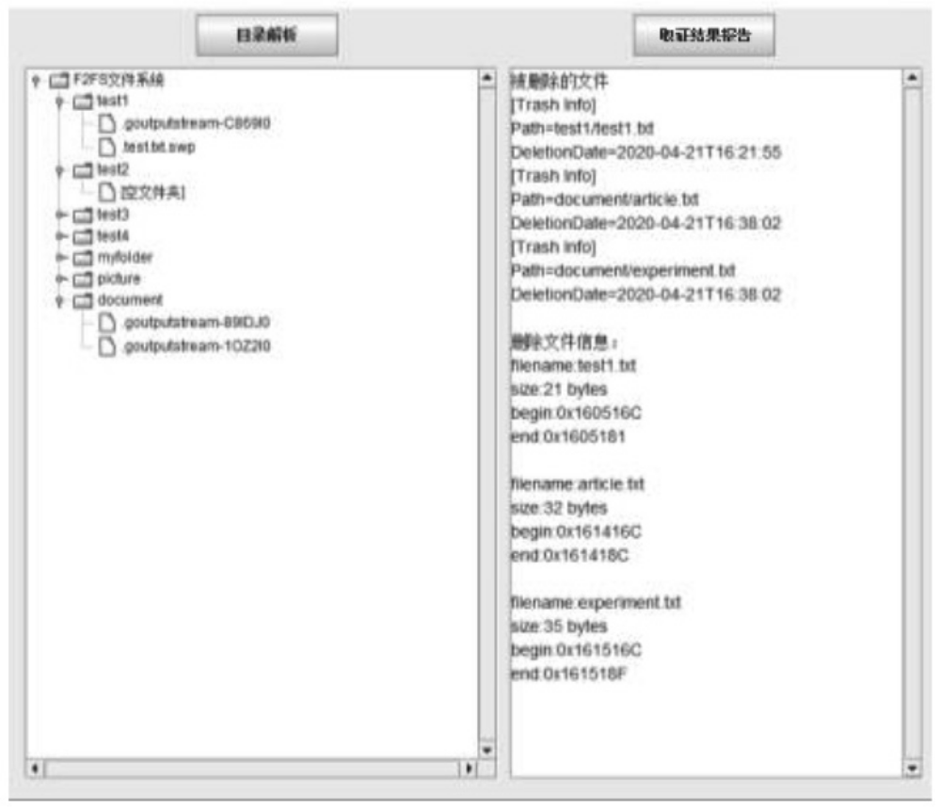
5.3 Analysis of average forensic time
As shown in Table 3, the universal F2FS mirror for mobile phones proposed in this paper Like file forensics methods, by locating valid folders and .Trash files Quickly analyze folders to obtain the user's current directory structure and recent deletions All file data information. The average forensic time of the method in this paper Approximately equal to the sum of time to locate each folder, order of magnitude of time Controlled at the millisecond level, and the average algorithm time of the method in this paper is only It is related to the number of files in the current system and is not affected by the file system. The size of the body, so the method in this paper analyzes the fetching of the image file The certification efficiency is higher. Especially when the system capacity is large, the initial state file Average evidence collection time of different methods
Mirror Type | Forensic Time of this article | Ergodic forensics time
Initial F2FS image file | 110 ms | 580 ms
Use F2FS for a period of time Mirror file | 130 ms | 580 ms
Large F2FS image file | 340 ms | 580 ms

The system and the mobile phone F2FS that has been used repeatedly for a period of time In the file system, this method is the same as the currently widely used disk traversal The search method is more efficient than the search method.
6 Conclusion
This article is based on F2FS's unique read and write access mechanism and mobile phone map The garbage collection mechanism of the shaped interface proposes a F2FS mirror file A general forensic method for data analysis. Through multiple sets of different types of mirrors Like data forensics experiments, the F2FS mirror forensics proposed in this article The method can effectively analyze the F2FS mirror file directory structure, accurately Quickly realize the forensic operation of deleted files, which has the function of F2FS forensics Significance.
基金项目：
1 . 国家自然科学基金“ 基于量化可信模型的信息系统智能安全机制研究” （ 项目编号： 616011131004911）；
2.信息通信与安全前沿科学研究中心资助；
3.至善青年学者支持计划资助。
参考文献
[1] C. Lee, D. Sim, J-Y. Hwang, S. Cho, F2FS: A New File System for Flash Storage [C]. Proceedings of the 13th Usenix conference on File And Storage Technologies (FAST' 15), 2015: 273-286.
[2] 张辉极.基于Flash存储的智能手机文件系统解析[J].电信科学,2010(S2):39-44.
[3] 潘泽汇; 陈明辉; 张辉极, 等. 一种通用F 2 F S 文件系统解析方法、终端设备及存储介质: 中国， 201711338307.2[P].2018-05-29.
[4] 梁效宁,许超明,赵飞,等.一种恢复F2FS文件系统中被删除文件的方法：中国，201711485304.1[P].2018-06-12.
[5] 刘卫华.大数据环境下的电子取证研究[J].科技创新与应用,2018,000(035):75-76.
[6] 黄少荣,陈丹.大数据环境下的电子取证研究[J].网络空间安全,2019,10(07):79-82.
[7] Liang Y , Fu C , Du Y , et al. An empirical study of F2FS on mobile devices[C]. 2017 IEEE 23rd International Conference on Embedded and Real-Time Computing Systems and Applications (RTCSA). IEEE, 2017: 1-9.
[8] 邓傲松.闪存友好型文件系统性能优化技术的设计[D].重庆:重庆大学,2018.
[9] 杨泽明,许榕生,刘宝旭.文件删除的恢复与反恢复[J].信息网络安全,2002,4:38-41.
[10] 刘春枚.基于计算机取证的Linux文件系统解析与设计[J]. 中国测试,2013, 39(S2):108-111.
[11] 李继伟.计算机取证磁盘镜像研究与虚拟仿真实现[D].重庆:重庆邮电大学,2016.
[12] 艾绍新.Windows数据恢复技术在电子取证中的应用研究[D].大庆:东北石油大学,2013.

作者简介：
翟雨佳（ 1 9 9 6 - ） ， 女， 汉族， 山西晋中人， 东南大学， 硕士； 主要研究方向和关注领域： 网络内生安全。
李涛（ 1 9 8 4 - ） ， 男， 汉族， 江苏镇江人， 东南大学， 博士， 东南大学网络空间安全学院， 副教授； 主要研究方向和关注领域： 可信计算、移动终端安全。
胡爱群（ 1 9 6 4 - ） ， 男， 汉族， 江苏如皋人， 东南大学， 博士， 东南大学， 教授； 主要研究方向和关注领域： 无线通信安全。

